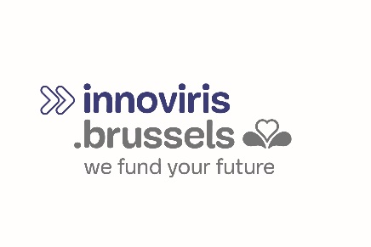
Chaussée de Charleroi 110 - 1060 Bruxelles  T +32 2 600 50 36  www.innoviris.brussels | Applicant’s logo

PROOF OF CONCEPT

FUNDING APPLICATION
Part 2 : Valorisation & IP

Acronyme

Table of Contents
1.1 VALORISATION PERSPECTIVES 2
1.2 PROVISIONS CONCERNING INTELLECTUAL PROPERTY RIGHTS 2

VALORISATION PERSPECTIVES
- Explain the exploitation perspectives for the results of this project in the Brussels-Capital Region.
- At the end of the project, what would be the technical developments to be implemented in order to obtain a Minimum Viable Product?

PROVISIONS CONCERNING INTELLECTUAL PROPERTY RIGHTS
- What is the current situation in terms of intellectual property rights?
- Draw up the list of patents already submitted and held by the organisation with details of:
  - the date of the application's submission
  - the application's submission number
  - the title of the invention
  - the countries of application concerned
  - the patent's date of issue, if applicable.
- Outline the rights to be acquired from third parties.
- What is the nature of the knowledge to protect or disseminate?
- Describe the approach that will be implemented to protect intellectual property.

